Practical – 9

Secure User Registration with Database Insert, Duplicate Email Check, and Password Hashing
Problem Definition : Implement secure user registration by inserting user details into MySQL using MYSQLi. Validate input on frontend and backend, check duplicate email/username, hash passwords using password_hash(), and display appropriate messages.
A. THEORY
1. Is password_hash() used before storing passwords?
Yes. The password_hash() function is used to convert the password into a secure hash before storing it in the database. The original password is not stored directly.
2. Is duplicate email/username checked?
Yes. The system checks whether the email or username already exists before creating a new account. This helps prevent duplicate user accounts.
3. Are frontend and backend validations consistent?
Yes. Both frontend and backend validations use similar rules for checking the user's input. Backend validation is also performed because frontend validation alone cannot provide complete security.

References
1. PHP Manual – password_hash()
2.PHP Manual – password_verify()
3. OWASP – Password Storage Cheat Sheet
4. OWASP – Input Validation Cheat Sheet

B. Implementation/ Output/Result
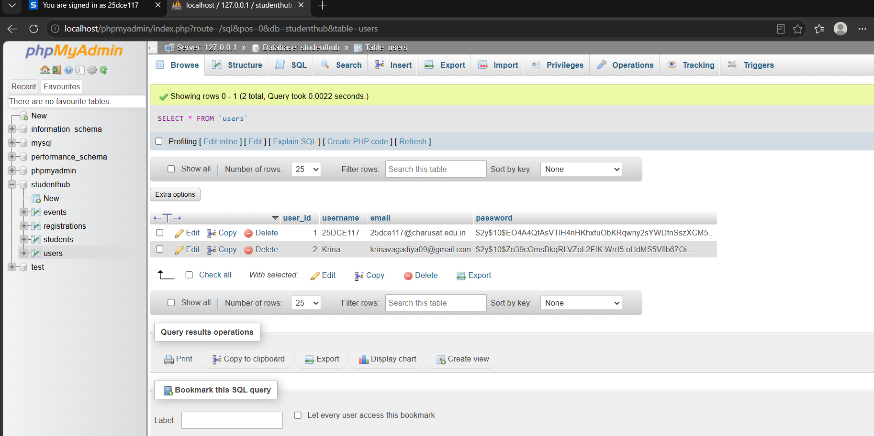

C. Evidence of Work (Screenshots)



D. GitHub Repository Link
https://github.com/NencyNVagadiya/Student-Hub-portal/blob/main/student.html

E. Challenges Faced:
“I faced difficulty in implementing duplicate username/email checking and securely storing passwords using password_hash(), as well as connecting the registration form with MySQL.”
F. Learning Outcomes:
Students will implement secure user registration following basic web security practices.

G. Faculty Remarks:

